Title, Font Cambria 12, Bold, Maximum 2 Rows, Align Left

Author¹, Author² [bold]
email_author¹, email_author²
¹Affiliation [author 1]
²Affiliation [author 2]

Article Information |  | Abstract
Received : (date)  Revised : (date)  Accepted : (date) |  | Abstract contains problem statement, approaches/problem solving method, objectives and results obtained. Abstract contains important information about the content of writing that is written briefly, concisely, and clearly in one paragraph, maximum 150 words. [Cambria 10, single space and justified].
Keywords
Maximum 5 words [Font Cambria 10, single space, align left]

- Introduction
The introduction includes background problems related to supporting theories (literature review) or previous studies (both from journals, as well as current phenomena/issues) as the basis for conducting research. The presentation of the introductory part that contains the background of the problem, theoretical basis, or related research does not have to be subtitled, but is integrated into a unified paragraph, and is presented in narrative form. At the end of the introduction, the purpose and usefulness of the research results are also explained. [Cambria 12, single space]

- Research Method
The research method explains briefly and clearly about the stages of research, including research design, instruments used, data collection techniques, analysis techniques, system design, and several other things related to research problem solving strategies. [Cambria 12, space 1]
Research methods can be supplemented by tables, graphs (pictures), and/or charts. The table does not contain vertical (upright) lines. Horizontal (flat) lines in the table are only found at the beginning and end of the table. Example of table format:

Table 1. Title [Cambria 12, space 1]
No | Identity | Type | Size
1 | Username | Varchar | 15
2 | Password | Varchar | 15
3 | Name | Varchar | 35
4 | Email | Varchar | 50
5 | Phone | Varchar | 15

[Table content writing format: cambria 10, space single]

Giving color to the graph or chart (picture) must be accompanied by a description of the meaning of each color. Example of image format:

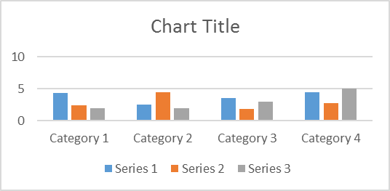

Figure1. Title [Cambria 12, space single, format png/jpg]

- Result and Discussion
This section contains the results of research and discussion, as well as the implementation of the developed system design. In addition, in this section the author should interpret the results of his findings, and confirm his findings with other existing findings or theories. [Cambria 12, space single]
- Conclusion
The conclusion contains a brief summary or main points of the writing and should not repeat what has been written in the discussion section. The conclusion contains the important results of the research, and contains the application and development of the research that has been carried out. [Cambria 12, spasi 1]

- Acknowledgment
Acknowledgment to those who have provided support for the research. [Cambria 12, space single]

- References
Articles must refer to at least 10 primary references published in the last 5 years. Writing a reference list must use the IEEE Mendeley style tool with the following conditions. [Cambria 12, space single]
Journal Article
- Z. Zhang, F. Wu, H.J.W. Zandvliet, B. Poelsema, H. Metiu, & M.G. Lagally, “Paper Title,” Physical Review Letter, vol. 74, pp. 3644-3677. 1995.
- G. Smith, “Paper Title” (to be published).
Electronic Publication, Information from the internet
- L. Weiss, Instruction to Authors, Elsevier Publishing,
http://www.elsevier.com/authors.html, 1999, retrieved May 13, 2010.
Conference Proceeding/Workshops
- C.H. Perry, F. Lu, F. Namavar, N.M. Kalkhoran, & R.A. Soref, “Paper Title” In Proceeding of ICACSIS 2011, pp. 456-541, 2010.
Monograph, edited book, book
- M.J. Carr, C.E. Lymar, & J.M. Cowley, In: J.M. Cowley (Ed.), Electron Diffraction Technique, vol. 1, International Union of Crystallography/Oxford University Press, New York, p.122, 1999.
- M.J. Adams, B.J. Briscoe, & S.K. Sinha, In: D. Dowson, C.M. Taylor, T.H.C. Childs, M. Godet, G. Dalmas (Eds.), Dissipative Processes in Tribology, Tribology Series, vol. 27, Elsevier, Amsterdam, p.223, 1994.
- D. Palik (Ed.), Handbook of Optical Constants of Solids II, 3rd ed., Academic Press, New York, p.151, 1991.
Theses, Dissertation
- R. Ramos, “Thesis Title,” Ph.D Thesis, College van Dekanen, University of Twente, The Netherland, 1992.
- S. Badu, “Thesis Title,” B.S Thesis, Department of Chemistry, Faculty of Mathematics and Natural Sciences, Universitas Indonesia, Indonesia, 1990.

